ADVANCED SOFTWARE ENGINEERING
CHALLENGE-1
0)
MUPPALLA JAYA SAI KRISHNA NALLURI KRISHNA CHAITANYA
ROLL NO:26 ROLL NO:27
ID: 16150480 ID:161557744

- DESIGN:
A) Architecture Diagram:
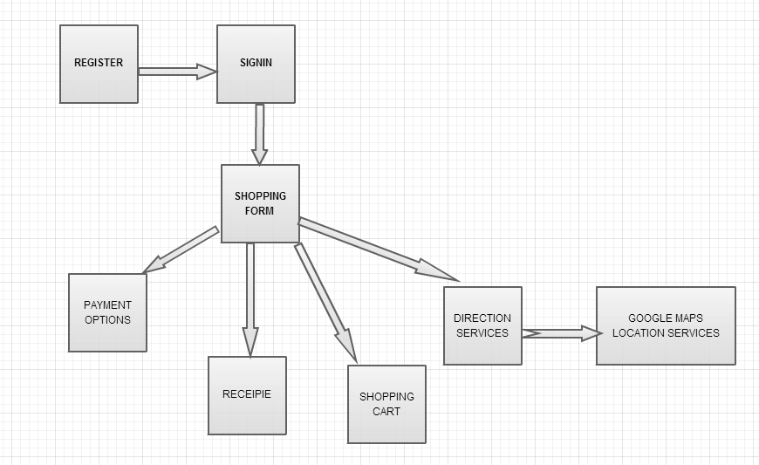

B) Class Diagram:
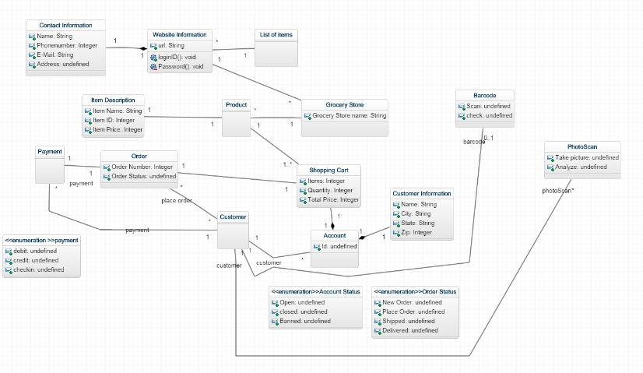

- FEATURES IMPLEMENTED:
Web Services:
We have created the user register and log in page with validations. We have included the features like grocery adding and removing. Created one search box to search for the groceries. By using the super market API you can find the products including images also. Included the payment options like debit, credit or Visa under payment. Included the direction and location services to find the location and direction of any place. We have used the recipie API also.

- SCREENSHOTS

Created the page for the Registration.

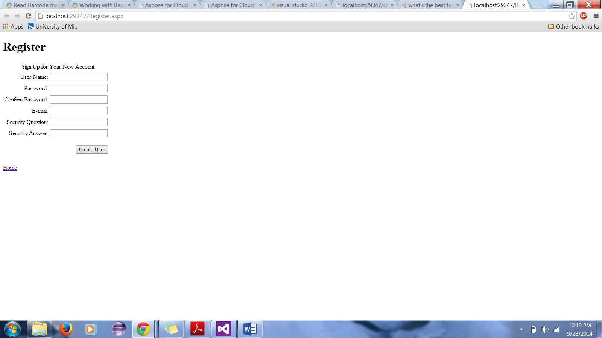

We have validated the Registration here.
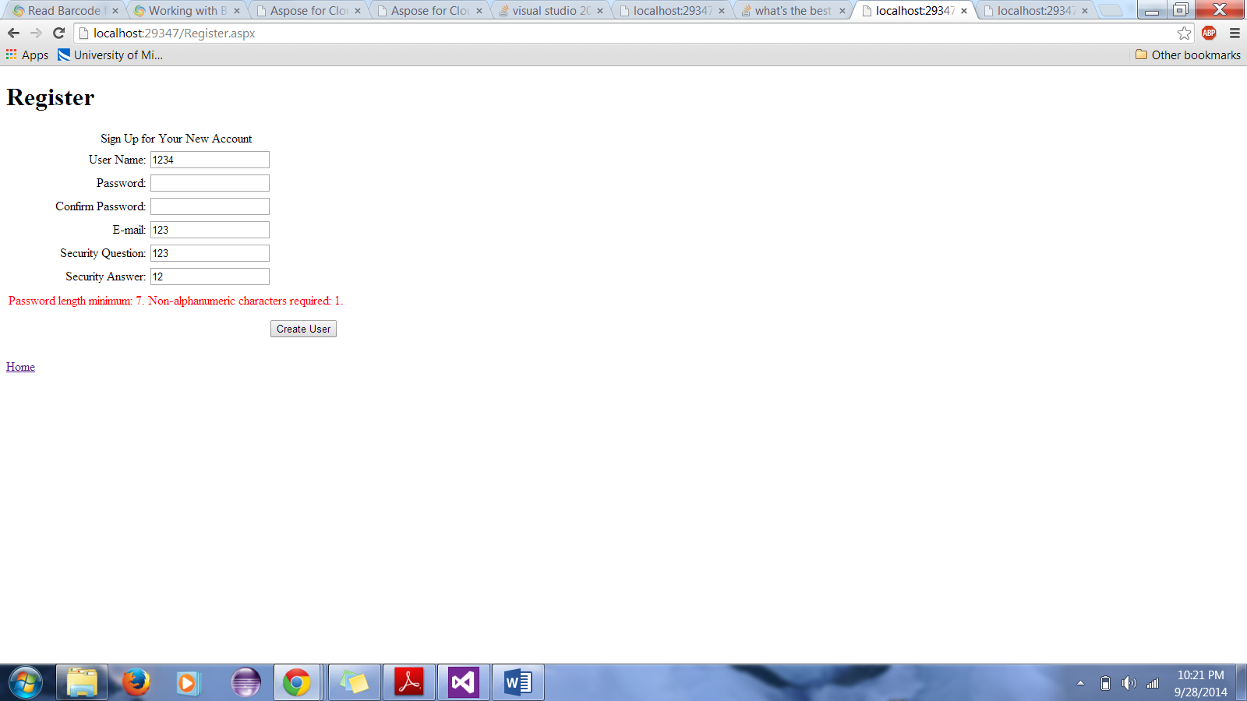

Created the page for the Login()

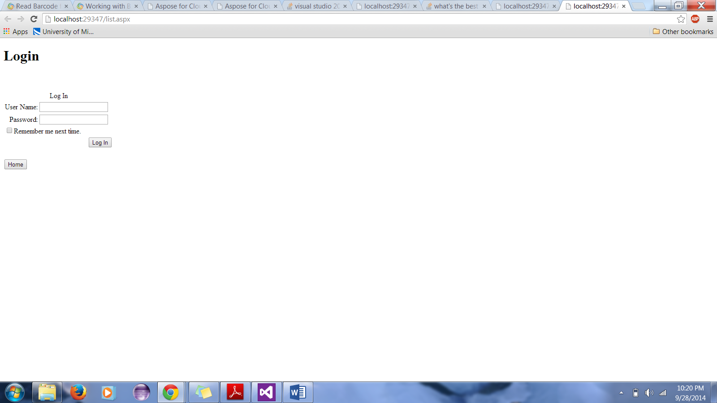

This is the validation for the Login page.
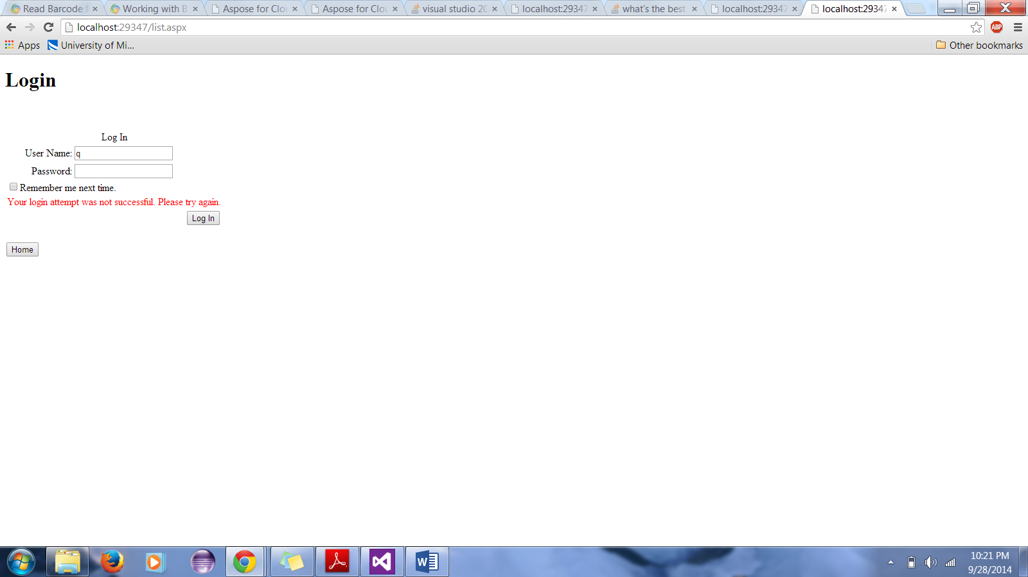

We have included category, Product, price and Quantity in the Shopping Cart.

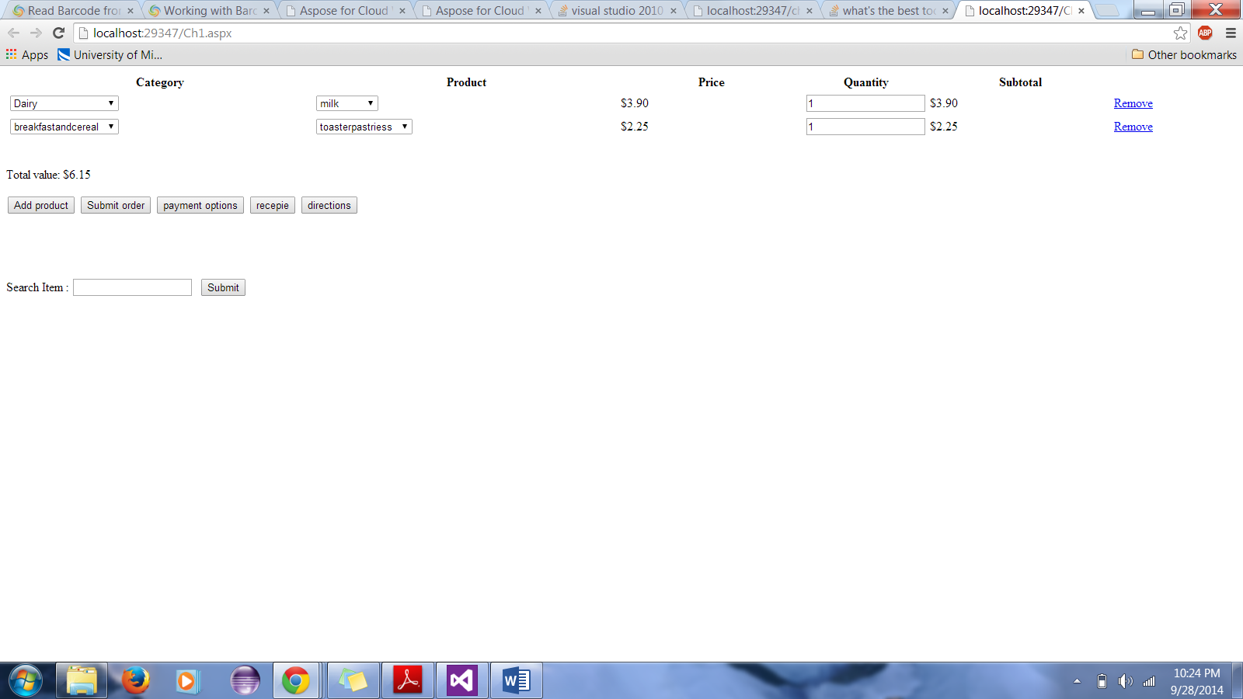

After we finalize the items in the shopping cart , once if we go to the submit button it appears like this.
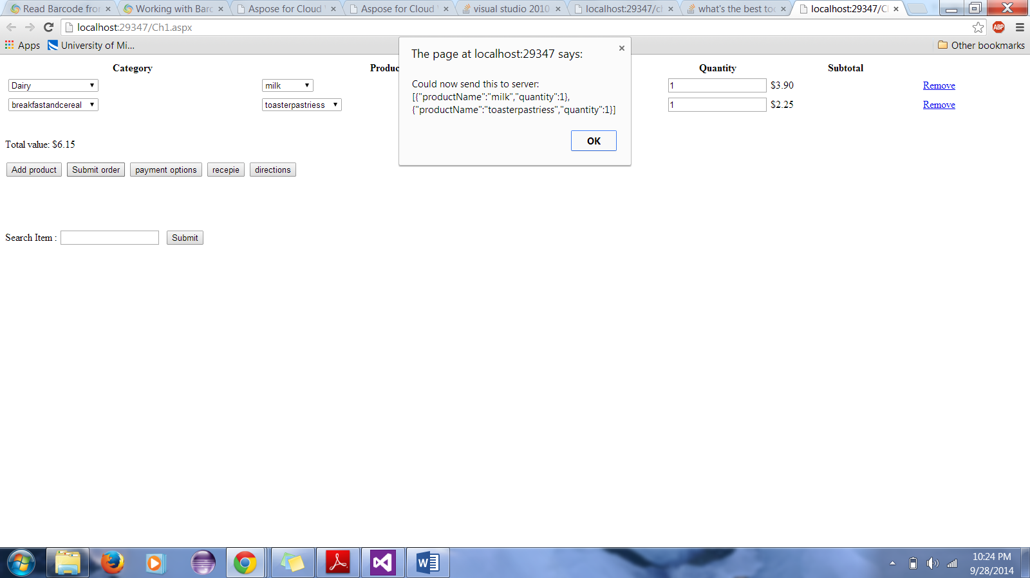
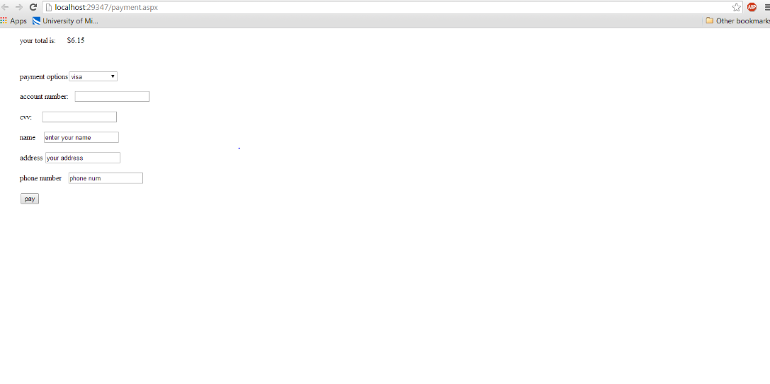

Using the supermarket API we can find the items or similar items.
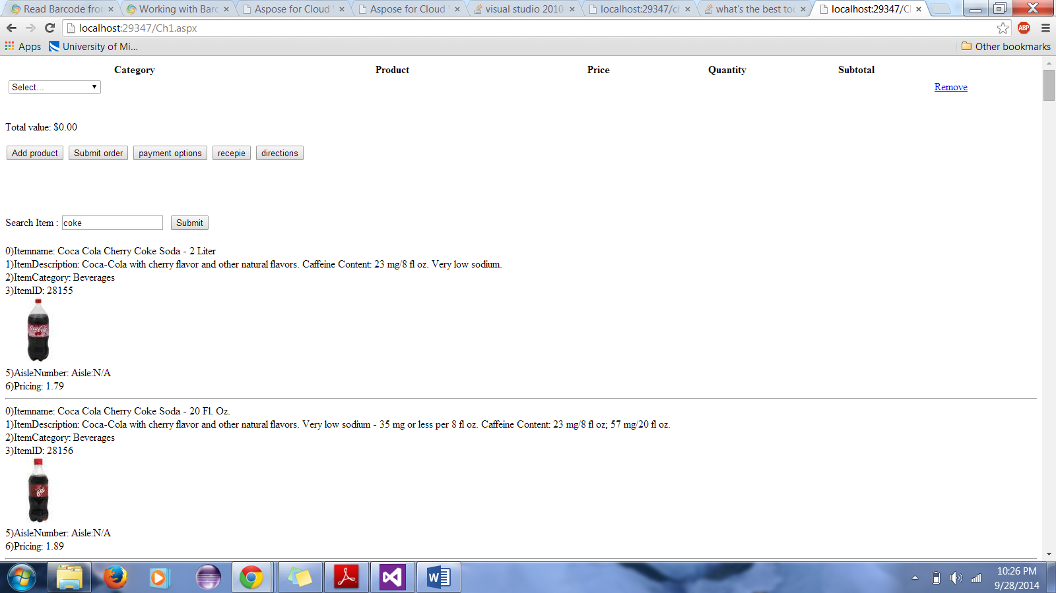

.

We have created Direction and Location pages using google maps API to find the direction to the particular place.
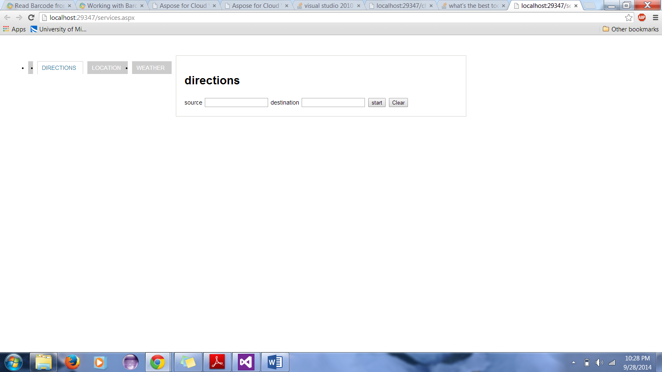

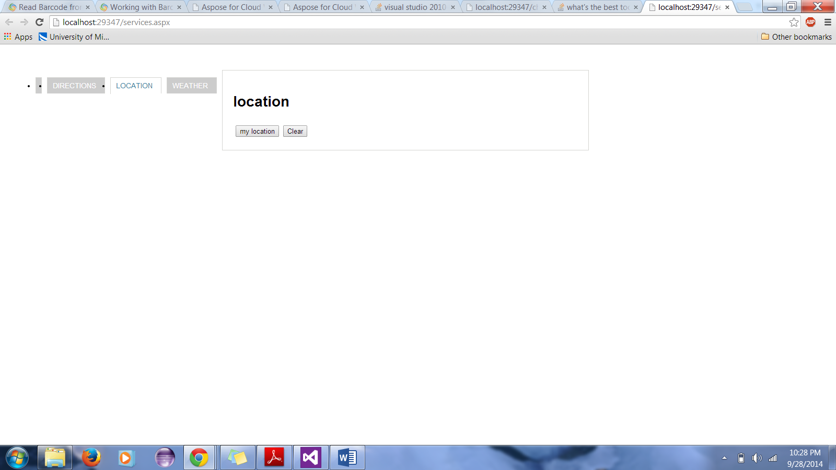

- CHALLENGE#1 GITHUB URL:
- LIMITATIONS
We cant find the API to the bar code scanner for the web application. We found one way but its lengthy as we have to first upload the image and then we have to process that image and then we have to get bar code using that one.
We found one recipie API but it is asking for authentication, time stamp and signature.

- REFERENCES
http://msdn.microsoft.com/en-us/library/hh534080.aspx
http://jsfiddle.net/jmmvd/82ucveme/3/

